# Homework: Bugs and Bug Tracking

## Bug Hunting: Google Home Page

|  |  |
| --- | --- |
| **Bug** | **Description** |
| **Bug #1** | There are missing page name and page favicon on the tab of the browser. |
| **Bug #2** | The “Gmail” text link is not placed correctly. It should be left of the “Images” text link. |
| **Bug #3** | There is missing dot in the center of the 9-dot menu in the top-right corner. |
| **Bug #4** | The icons on the right side inside the search bar are different. |
| **Bug #5** | The magnifying glass inside the reach bar is reversed. |
| **Bug #6** | Wrong color of the letters “g” and “l” in the Google text. |
| **Bug #7** | The buttons “Google search” and “I’m Feeling Lucky” should be in Bulgarian. |
| **Bug #8** | Text “Bulgaria” on the left bottom corner has wrong font. |
| **Bug #9** | The buttons in the bottom of the page should be in Bulgarian. |
| **Bug #10** | In the left bottom corner there are missing “Advertising” and “Business” buttons. |
| **Bug #11** | In the left bottom corner there is two times “How Search works” button. |
| **Bug #12** | In the right bottom corner, there is missing “Privacy” button. |

## Bug Hunting: Notepad Application

|  |  |
| --- | --- |
| **Bug #1** | Wrong icon on the left corner. |
| **Bug #2** | The name of the file is missing. |
| **Bug #3** | The “View” menu is missing. |
| **Bug #4** | The zoom in and zoom out buttons are missing. |
| **Bug #5** | The “X”-close button has wrong font. |
| **Bug #6** | The “Exit” button is missing in “File” menu. |
| **Bug #7** | The shortcuts on “Open” and “Print” buttons are missing. |
| **Bug #8** | The arrow in the right bottom corner should not be in red color. |
| **Bug #9** | In the right bottom corner, there are missing dots. |
| **Bug #10** | The text in the bottom should be aligned right not aligned left. |

## Bug Reporting: Gmail

|  |  |
| --- | --- |
| **Bug ID** | GM-1 |
| **Priority** | Medium |
| **Severity** | Medium |
| **Assigned to** | Unassigned |
| **Reported by** | Gabriela Velinova |
| **Reported on** | 21.01.2023 |
| **Status** | New |
| **Environment** | Microsoft Windows 10 Pro - 10.0.19044 Build 19044  Firefox Browser - 109.0 (64-bit) |
| **Summary** | Wrong redirect on Gmail login. |
| **Description** | As not logged user, when I login in Gmail I want to see my inbox with all unread and read messages, but I am redirected to Google.com |
| **Expected behavior** | When I login to Gmail, I should see my inbox with all unread and read messages. |
| **Actual behavior** | When I login to Gmail, I am redirected to Google.com. |
| **Steps to reproduce** | 1. Open Gmail.com; 2. Fill-in username and password (…); 3. Wait for redirection; 4. See the result. |

## Bug Reporting: Reset Password

|  |  |
| --- | --- |
| **Bug ID** | SP-1 |
| **Priority** | Medium |
| **Severity** | Medium |
| **Assigned to** | Unassigned |
| **Reported by** | Gabriela Velinova |
| **Reported on** | 21.01.2023 |
| **Status** | New |
| **Environment** | Android 12, One UI 4.1  Samsung Internet Browser – 19.0.6.3 |
| **Summary** | Mobile users receive two email on registration |
| **Description** | As non-registered mobile user, when I register I receive two emails for resetting my password. It should be only one. |
| **Expected behavior** | When I register via mobile device, I should receive one email for password reset. |
| **Actual behavior** | When I register via mobile device, I receive two emails for password reset. |
| **Steps to reproduce** | 1. Open the website on mobile device: samplepage.com; 2. Register as a new user. 3. Open personal Inbox. 4. Find two password reset mails there. |

## Register in Atlassian Jira Cloud

Go ahead. Register. We already showed you how. 😊

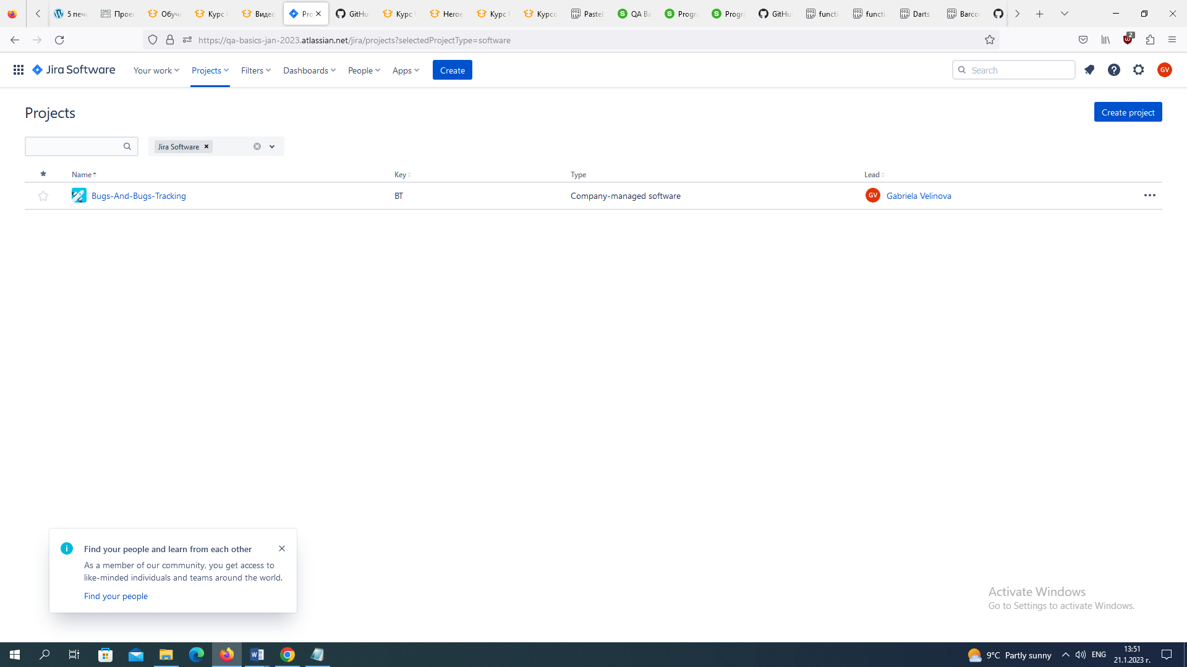

## Bug Reporting: Registration Form

Report all bugs found in your Jira project.  
Optionally you may also describe bugs in the table below or **attach** **screenshots.**gabi123

[gabi@g.com](mailto:gabi@g.com)

Gabi11!

|  |  |
| --- | --- |
| **Bug** | **Description** |
| **Bug #1** |  |
| **Bug #2** |  |
| **Bug #3** |  |
| **Bug #4** |  |
| **Bug #5** |  |

**Environment**

Microsoft Windows 10 Pro - 10.0.19044 Build 19044

Firefox Browser - 109.0 (64-bit)

## Template for Jira Bug Report:

#### (Detailed Description)

…

#### Expected behavior:

…

#### Actual behavior:

…

#### Steps to reproduce:

1. …
2. …
3. …

#### Environment:

Microsoft Windows 10 Pro - 10.0.19044 Build 19044

Firefox Browser - 109.0 (64-bit)